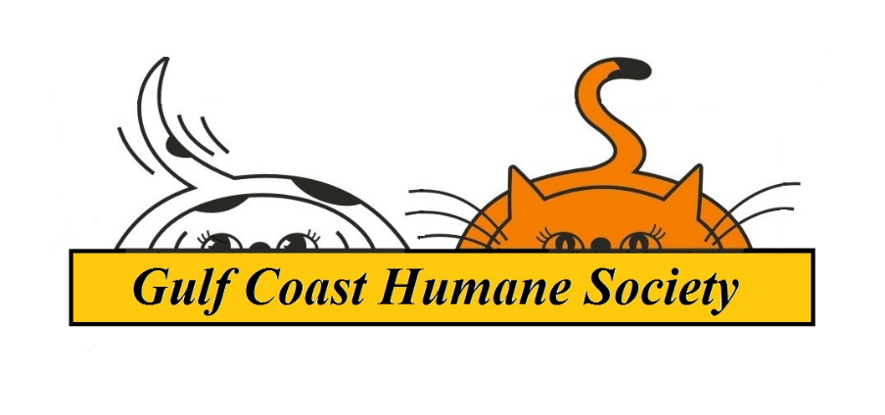
Volunteer Handbook
Gulf Coast Humane Society

Gulf Coast Humane Society
Volunteer Handbook
Updated: November 2021

Contact and Address Information:

Phone: (361) 225-0845; Fax: (361) 225-0945
3118 Cabaniss Parkway, Corpus Christi, Tx 78415

Hours of Operation:

Monday – Saturday: 11am to 6pm
Sundays: 12pm to 5pm

Volunteer Staff Contacts:
Amy Sanders–Volunteer Coordinator
Email: volunteer@gchscc.org
Cell (emergencies only): (936)402-5337

Volunteer Program Mission Statement:

The Gulf Coast Humane Society’s volunteer program exists to better enrich the lives of the animals while in GCHS care, as well as utilizing individual talents to assist in shelter operations and support teams.

History of the Gulf Coast Humane Society:

The Gulf Coast Humane Society (GCHS) was established in 1945 in response to the growing numbers of homeless pets in Corpus Christi. With the generous donation of Tom and Cora Keeler, we moved from our location on Navigation Rd to our current location. We strive to provide the best care for the animals that come in our doors. We are the largest no-kill shelter in South Texas and believe every animal has a chance to be a part of a loving home. As a no-kill facility it is mandatory that we are a limited intake shelter. We are a non-profit, 501 (c)3 organization and we rely directly on donations and assistance from the general public. We believe our animals are family and require adequate medical care, access to food and clean water, responsible guardianship and most of all, love.

Gulf Coast Humane Society Services:

All of our adoptions are a complete package.
- Every animal is spayed or neutered
- Up to date on vaccinations
- Dewormed
- 6 month supply of Heart Worm prevention
- Heart Worm treatment for HW+ dogs
- Free wellness exam at most local vets
- Microchip

Volunteer Policies and Procedures
Age Requirements:

All volunteers must be at least 8 years of age to accrue hours in the volunteer program. Those under 12 years must always be accompanied by a parent or legal guardian (no siblings or anyone under the age of 18). Volunteers’ ages 12-17 may volunteer independently right away, all must have parental consent. Certain areas of the volunteer program require members to be at least 18 years of age for liability purposes. Parents or Guardians are welcome to bring children under 8 years of age to accompany volunteering with a maximum of 2 minors per parent/legal guardian. Parents or Guardians must sign liability paperwork for all minors attending volunteer hours. GCHS also would like to remind parents and guardians that the volunteer program is very independent and there will not be a staff member to accompany your child if you choose to leave them to volunteer on the premises unsupervised. Likewise, a parent or guardian with accompanying minors of any age is solely responsible for the minors accompanying them and their safety.

Volunteer Fees:
The Gulf Coast Humane Society requires volunteers to pay a fee; which covers volunteer shirts and volunteers supplies. The fees help fund the volunteer program and allow more resources to be expended on the animals. A solid color shirt is provided for new volunteer and volunteers reaching 40 (tie dye), then 100 hours (gold) are gifted shirts.
Fees: $10

Commitment and Hours:

We ask that everyone try to log one hour a month to remain active. If you have not been active in three months you will receive an e-mail about your willingness to continue to volunteer. If you are not active within three months you status will be changed to inactive. Once your status has been changed you are welcome to return at any time, just contact the outreach manager or volunteer trainer for a “refresher” meeting.

Training Requirements:

To become trained as a volunteer for GCHS you must complete the following requirements;
read this handbook, complete safety training and a kennel support shift. If any scheduling conflicts exist contact the volunteer coordinator and accommodations may be made.

ALL VOLUNTEERS ARE REQUIRED TO GO THROUGH TRAINING. DO NOT BRING FAMILY OR FRIENDS WITH YOU TO VOLUNTEER that have not gone through training. They will be asked to leave. If they would like to become a volunteer they must complete training.

Once completed, if you are comfortable going in and out of the kennels, you are eligible to volunteer during shelter hours as well as kennel support shifts. If you are still unsure you can set up a shadow with a Volunteer Ambassador. The more hours you log the more benefits/opportunities you accrue, which will require further training.

Scheduling and Time Tracking:

Volunteers are to use Signup.com to sign up for trainings and kennel support. Volunteers will use Volunteer Buddy to track hours as of August 2019. Volunteers are responsible for keeping track of their own hours checking in and out each time they volunteer. If a volunteer does time away from the shelter (ex: events) they are responsible for contacting the Volunteer Manager via e-mail to have those hours plugged into the Volunteer Buddy System. Volunteers will be walked through how to log on and off the Volunteer Buddy systems at safety training and must have a working e-mail to log hours.

Needs and Volunteer opportunities:

Kennel Support Shift 9am – 11am every day:
Strongly recommend to do at least once prior to Exercise and Socialization. This shift occurs during the very beginning of the day, during this time volunteers and staff prepare for opening the shelter to the public. Dogs are taken out to relieve themselves, kennels are cleaned and dogs are fed. Volunteers can become accustomed to taking the dogs in Puppy Condo in and out of the kennels, on walks, and doing the leash wrap (taught at the one on one safety meeting) during this time.

Exercise and Socialization:
Exercise and Socialization is the main task that volunteers do at GCHS. You can come during open hours (Monday - Saturday 11am-6pm; Sunday 12pm-5pm) to spend time with our dogs. GCHS has such a small amount of staff that they can only care for the animals essential needs, that's where the volunteers come in. Exercise and socialization includes: playing at the GCHS dog park (for shelter dogs only), walking dogs, play time, giving treats, petting or even just sitting with a scared dog for a few minutes. There is no schedule or time limit is required. You might only spend time with one dog, but it makes a world of difference for that one animal.

Events, Fundraisers, and Community Support:
GCHS participates and holds events all year long to keep the community involved and engaged in our cause. These events and fundraisers are not possible with our volunteers! Throughout the year we hold adoption events at the Home and Garden Show, Half Price Books, Realms Con and many more. We also attend community events like the monthly Harbor Bridge walk, visiting the residents of Waterford Assisted living and helping kids practice reading with our Read and Rollover program. Community Outreach Pet Clinics are held once a month at various locations in the Coastal Bend and also need lots of volunteer help.

Virtual Foster:
Volunteers who love to post on social media can accumulate up to 5 hours a week by becoming a Virtual Foster! Volunteers can pick a specific animal to “foster” via social media, becoming their online cheerleader to try and get them adopted. Virtual Fosters must sign up through the Volunteer Manager, adhere to a few guidelines, and post once a day (tagging the Gulf Coast Humane Society) for 7 consecutive days to receive the 5 hour credit. Posts can be on their personal account or one they created specifically for their virtual foster project.

Field Trip Fun (40 plus hours)
Once you have reached 40 hours you are considered a permanent part of our team! As a “Thank you” you get the privilege of taking our dogs off the property. You may take ONE dog to any place that is dog friendly: the beach, Half Price Books, the park, etc. Must be over 18, have valid driver’s license and able to leave a “deposit”. You will be charged a late fee if dog is not returned an hour before closing.

Exercise and Socialization, Kennel Safety, Shelter Rules and Operations

Please note that all training is done in the safety meeting. All safety procedures, hands on training, walking locations, etc. are all reviewed in the one on one. The following are just reminders.

Walking Boundaries: Volunteers are only permitted to walk around the perimeter of GCHS and no farther than the natatorium parking lot. The side gazebo and Dog Park are also available for volunteers to socialize with the dogs. Any longer walks away from GCHS property need to be cleared with the volunteer coordinator. Please familiarize yourself with the walking map. Do not linger in hallways, lobbies or tight areas in the shelter.

Dog Park Etiquette: The dog park is SHARED between staff and volunteers the dog park is also utilized for meet and greets between staff and potential adopters. If you are in the park and see a staff member with a customer intent on using the park, please immediately leash up your dog and exit the park until the meet and greet is over. If you have been in the park for at least 15 minutes, please be aware of those waiting to get in and allow them their time. Never enter the park with a dog when there is already a dog in the park. Never mix dogs from separate kennels in the park.
Walking Dogs: Never let dogs meet each other (sniff each other or meet noses), never mix dogs from separate kennels, and always use a leash wrap (no matter what you see others doing). When passing others with your dog keep leash tight and close to you, do not let you dog sniff or jump on other people. Do not let you dog pull you around.

Socialization: Never assume you know an animal. Keep you face away from all dogs faces. Talk to staff about dogs personalities if you are unsure how to treat him/her and always read all signs posted around the shelter. Do not socialize/touch/handle any animals brought in by the public, as they may have something contagious.

Volunteer Rewards and Recognition:

We want to say thank you to our most dedicated volunteers and give them the recognition they deserve. The more hours you log the more rewards and privileges you receive. At the end of the year we have a volunteer and foster parent appreciation where awards will be handed out.

Volunteer Communication:

You will find all the tools you need to volunteer; leashes, toys, treats, etc. right outside the Volunteer office.

Please provide an e-mail that you check on a regular basis on the volunteer application as that is the e-mail that all event information and correspondence will be sent to.

Meetings:

We will have volunteer meetings based on what type of volunteering you will be participating in.

Visitors and Personal Guests:

Only GCHS approved volunteers are allowed to handle dogs. Do not bring friends or family to volunteer with you. If you want to bring a friend or family member with the intention of facilitating an adoption, an adoption specialist must accompany you. We encourage all volunteers to recruit more volunteers, friends and family are welcome, but they must complete training.

Dress Code and Personal Belongings:

Volunteers are required to adhere to the dress code, for important safety reasons. The dress code is as follows:

- Close toed shoes, preferably with non-slip soles
- No sleeveless shirts or tank tops
- Jeans or appropriate shorts
- No baggy shorts or pants allowed
- Volunteer shirt REQUIRED for proper identification between staff and customers
- Any article of clothing (hats, jackets, belts, accessories, etc) with vulgar or profane language or graphics will not be tolerated.

Volunteers are encouraged to leave purses and bags at home, but such items can be stored in an appropriate place if needed.

* You are responsible for your own belongings. The Gulf Coast Humane Society is not responsible for lost or stolen items on shelter property. This is a public place, please use your discretion and do not bring items of value.

Social Media Etiquette:

Facebook and other social media outlets are extremely important in spreading the message of the Gulf Coast Humane Society, as well as highlighting our adoptable animals. We encourage our volunteers to share our official Facebook posts and pictures on their personal pages, however we do not allow volunteers to speak on behalf of GCHS in public forums including, but not limited to: local news sites, other rescue’s posts or sites, or any form of media without the consent of a manager at the Gulf Coast Humane Society. Any negative misinformation communicated by volunteers can result in termination from the volunteer program.
Social Media has become the #1 way that most of our animals get seen and then adopted, your post or picture can change our animal’s lives forever. Please note the following Social Media Outlets:

Facebook : The Gulf Coast Humane Society (there is also one in Florida, make sure it’s the right one)
Instagram: @gchscorpuschristi Please feel free to hashtag also, you might see your post on our official page! #gchscc

Photography:

Volunteers are allowed to take pictures of their own. We DO NOT allow pictures of sick animals, animals in rehabilitation or animals in distress to be taken. Taking these pictures can result in termination from the volunteer program. Remember: pictures posted on social media sites, including your personal accounts need to reflect the positive message of the Gulf Coast Humane Society. Your short video or picture can make the difference of a life time for our animals.

Confidentiality:

As a volunteer, you may have access to information and documents that may be confidential including donor information, adoption records, etc. All volunteers must sign a confidentiality agreement in which the divulging of confidential information may result in termination from the volunteer program. Additionally, volunteers may also have access to information about animals that are not yet ready for adoption. Volunteers may not disclose to members of the public any information on animals that are not yet available for adoption.

Grievance Policy:

The purpose of the grievance policy is to maintain an atmosphere of open, two-way communication between staff and volunteers, to foster an environment of trust and to resolve volunteer issues and concerns in a timely manner. You are encouraged to raise concerns directly to the volunteer coordinator as soon as possible after an event of concern occurs.

Volunteer Pet Adoptions:

All volunteers are eligible to adopt an animal. Adoptions for volunteers will be handled exactly like any other adoption for a GCHS customer. All adopters must go through an application process and pay the necessary adoption fees.

Transmission of Disease:

While volunteering at the Gulf Coast Humane Society you may come into contact with diseases communicable to humans and/or to household pets. While this is not much of an issue if your animals are current on vaccinations, all volunteers should take extra precautions and change or wash any clothes and shoes worn during your time at the shelter.

Volunteering or Visiting other shelters/rescues:

We maintain a high level of cleanliness in our facility and ask that if you volunteer or visit another animal shelter, you wait 24 hours before coming to GCHS to prevent the spreading of any possible diseases.

Bite/Scratch Reporting:

It is required by GCHS and the city of Corpus Christi that all bites or scratches that break the skin, whether intentional or not, must be reported immediately upon injury. If you are bitten or scratched, please report to the Front Office or a shelter manager to fill out an incident report.

Dog Fights:

We take every precaution we can to avoid dog fights. This is why volunteers are never allowed to let dogs meet each other (sniff each other, or meet nose to nose) or mix dogs from separate kennels. Yet dog fights are still possibility. Do not break up a dogs fight. Get help; yell for a staff member or call the front desk.

Runs:

Each dog goes outside to the runs for 2 hours. If a dog you would like to walk is outside in the runs, please do NOT interrupt their time by taking them out of the runs. Focus your time on a dog still cooped up in a kennel and allow them time to stretch their legs. If you would like to play with a dog that is in the runs, get permission from the volunteer coordinator or a staff member first.

Treats and Rewards:

Volunteers are allowed to bring their own treats to use with our dogs, however there are a few restrictions. Treats MUST be approved by the volunteer coordinator and fall under these guidelines:
- Must be made in the USA
- Absolutely NO rawhides or chewing bones

Keep in mind, our dogs are fed separately for a reason, we need to do everything we can to prevent fights. Do NOT give treats to a dog while they are still in the kennel, make sure you have stepped out of the kennel and are safely away from other dogs. Do not let younger volunteers give treats until you know the dog will take the treat gently. Protect your fingers; hold your hands out flat when dispensing treats!

Volunteer Code of Conduct:

- Should a customer approach you while walking a dog or walking through the kennels and is interested in adoption, politely direct them to a staff member who can assist them.

*please note: You should always make sure the animal you have is safe first and foremost. If your dog seems uncomfortable with a customer approaching please feel free to let the customer know not to pet “your dog.” When you take GCHS dogs out they are “your dog” for that short amount of time, it is your job to keep them happy and safe.*

- Volunteers are not permitted to share any medical information on ANY dog at the shelter to members of the outside public (it is against the law). All customers need to be directed to a staff member with any questions.

- While here on volunteer time, your primary goal is to make our animals happy (and have fun doing it). Please refrain from lounging in staff areas like the Back Kennels break room or the Staff break room too often, as it distracts the staff from their day to day duties.

- Should you notice an injury or have any concerns about an animal’s health, please notify a staff member in that area immediately.

- Profanity will not be tolerated. We are a family oriented establishment; conversations need to be kept professional and light. Please be considerate of the children in and out of our building.

- Cell phones are permitted, however, not recommended as they can cause distractions. Please be sure to always be aware of your surroundings and other dogs in your immediate area. Keep cell phone use to a minimum.

- NEVER strike, slap or hit an animal. We only use VERBAL and gentle touch corrections. ANY form of abuse, including but not limited to: yelling, beating or inappropriate handle of an animal will result in immediate termination from the volunteer program.

- Safety is always the first priority for GCHS. Any violations of our safe handling procedures will result in a verbal warning. Continued failure to follow safety precautions and GCHS policies will result in termination from the volunteer program.

*** All Information is Subject to change as new branches are added to the Volunteer Program. It is your responsibility to check your e-mail regularly for updates, rule changes, and new volunteer program information. ***

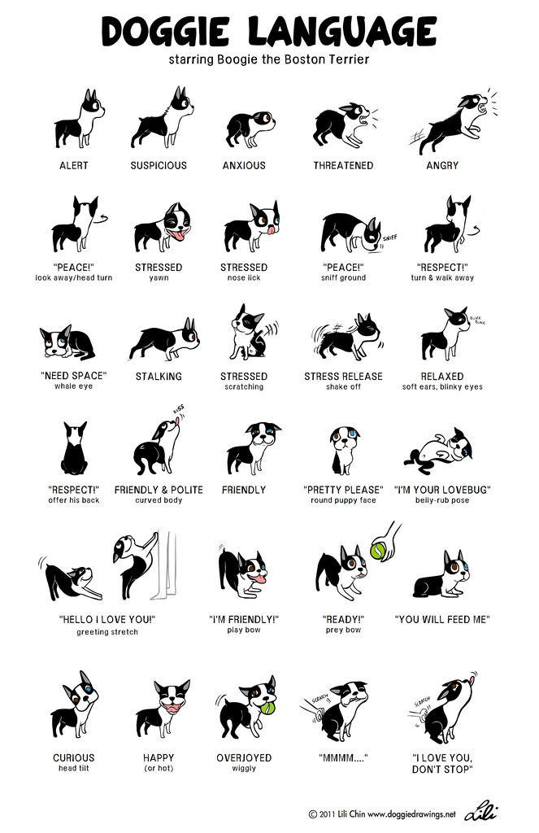
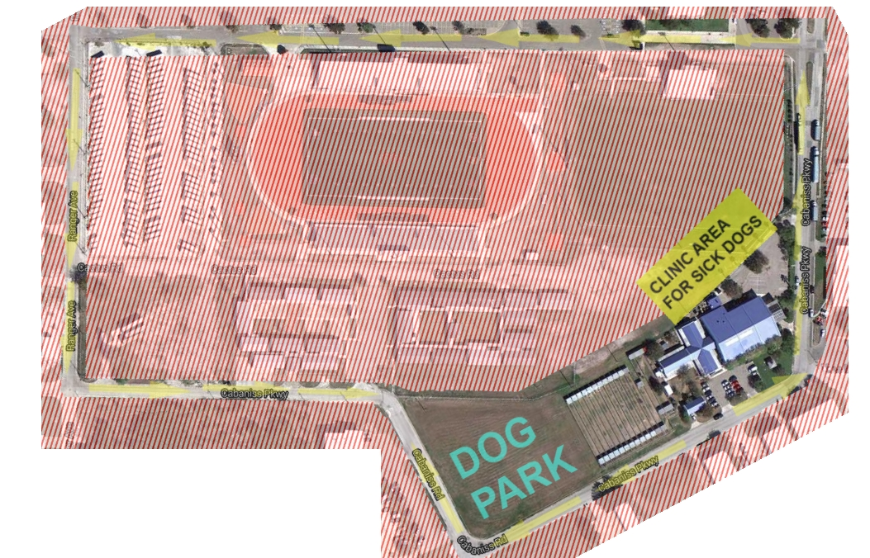
Map of the Walking Boundary

Volunteer Handbook Contract, Terms and Conditions

I have read and understand the policies and procedures outlined in the Volunteer Handbook.

I understand that I am responsible to track my hours and will not rely on GCHS to keep track of my accrued volunteer hours

I understand that divulging any information I come across about animals not ready for adoption, potential adopters, any information regarding an animals medical history or any shelter business to the general public (and on social media sites) will result in termination from the volunteer program. I will direct any questions from customers regarding the personality and medical information of an animal to Front Office or shelter staff.

I understand that I am responsible for my personal safety and any minors under my care as well as the safety of the dogs or cats in my care. I will never strike an animal, or handle or treat an animal in such a way that it would be construed as rough or abusive nor will I allow any minors under my care to do so. I will always exercise care and compassion with the animals.

I am physically and mentally capable of understanding the proper way to walk/handle an animal and will not go above and beyond my physical limitations.

I will keep distractions to a minimum and will remain fully aware of my surroundings at all times.

I understand that I will need to report any bite that breaks the skin, whether intentional or not, for liability purposes. I will report any accidents or unsafe conditions I witness to a staff member or volunteer coordinator.

I will always maintain the positive mission of the Gulf Coast Humane Society and promote proper pet care and education, as well as exhibit a courteous and positive attitude towards staff, customers and other volunteers.

I understand that GCHS reserves the right to terminate my volunteer status as a result of the following: any abuse or mistreatment of an animal, failure to comply with GCHS policies and regulations, inappropriate attire or attitude or behavior, any other circumstances which in the judgment of GCHS would make my volunteer service contrary to the best interest of GCHS, inability to fulfill shelter needs or duties assigned or not coming in to volunteer within 3 months’ time.

I have read and understand each of the above conditions. My signature below indicates I agree with the above stated contract, terms and conditions. I further understand that I am making at commitment to the agency (animals) even though I am a volunteer.

Printed Name: ___________________________________________________ Date_____________

Signature: ________________________________________________________________________

Date issued handbook: ___________________________

Parent/Guardian signature if under18:______________________________________________

Gulf Coast Humane Society
Release and Waiver of Liability

This Release and Waiver of liability executed on this______day of _____________, ___________ (year)
By(volunteer)____________________ in favor of the Gulf Coast Humane Society , a nonprofit corporation organized and existing under the laws of the state of Texas, USA.

I, the Volunteer, desire to work as a volunteer for GCHS and engage in the activities related to being a volunteer for any assigned project I wish to work on. I hereby freely and voluntarily, without duress, execute this release under the following terms:

1. Waiver and Release: I, , release and forever discharge and hold harmless the Gulf Coast Humane Society and its successors from any and all liability, claims and demands of whatever kind of nature, either in law or in equity, which may arise or may hereafter arise from my work at GCHS.

2. Insurance: I understand and acknowledge that this Release discharges GHCS from any claim or that I , the Volunteer may have against GCHS with respect to bodily injury, personal injury, illness, death or property damage that may result from my participation in volunteer activities. I also understand that GHCS is not liable for my (the volunteer) medical expenses. Claims for such incidents should be taken up with the Volunteer’s own insurance carrier.

3. Medical Treatment: I hereby release and forever discharge GHCS from any claim whatsoever that may arise or may hereafter arise on any account of first-aid treatment or other medical services rendered in the connection with an emergency during my volunteer time with GCHS.

4. Assumption of Risk: I hereby expressly and specifically assume the risk of injury or harm in these activities and release GHCS from all liability for injury, illness, death or property damage resulting from my volunteer activities and participation. I completely understand that there are activities that may be hazardous to me. I understand that working with shelter animals poses a risk of being bitten, scratched or hurt.

5. Photographic Release: I grant GCHS all right, title and interest in any and all photographic images, video and audio recordings made by GCHS during my volunteer shift.

*A note for Parents/Guardians: Our program is very independent. Please note that there will not be anyone to watch your child directly while they are volunteering. It is your responsibility as their parent/guardian to trust that they will follow all rules, conduct, and remain on the premises while they are volunteering if you are not present. If you do not trust that your minor will follow your direction, GCHS is not liable if they leave the premises at any time while they are supposed to be volunteering.*

By signing this form, I am acknowledging my understanding of this document.

Volunteer Name: (print) __________________________________Signature: _________________________

Date: _______ Parent/Guardian signature if under18:_____________________________________________

